**WireFrames:**

Sign in page

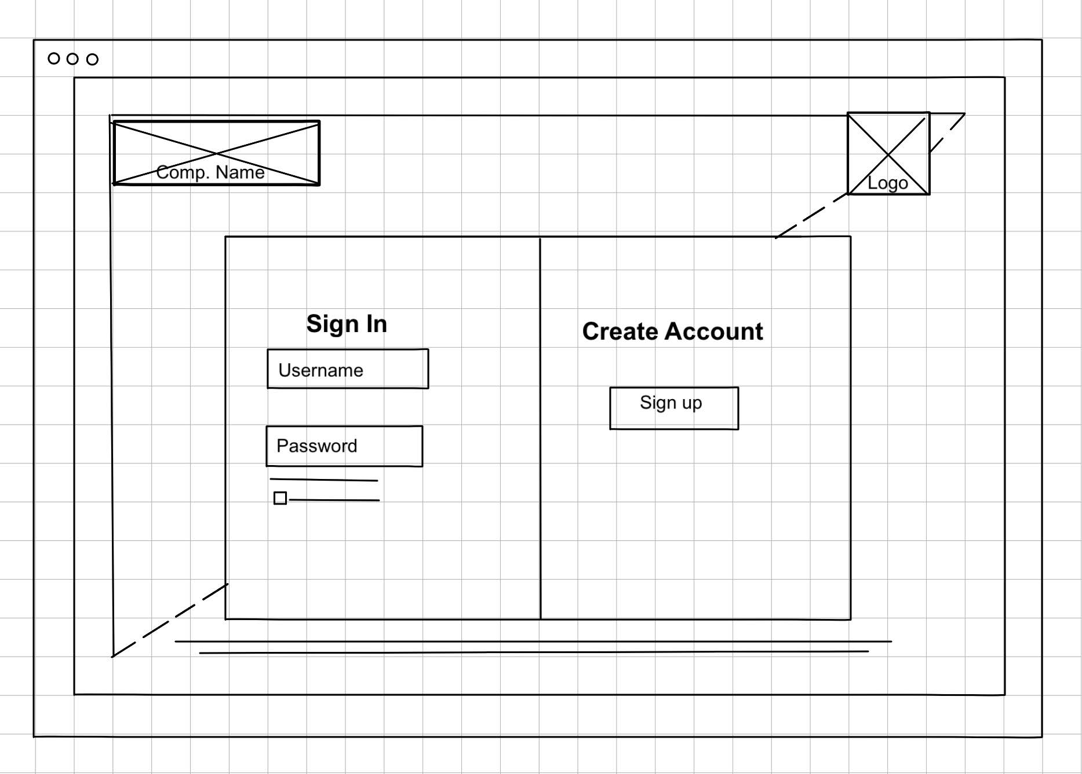

Profile Page

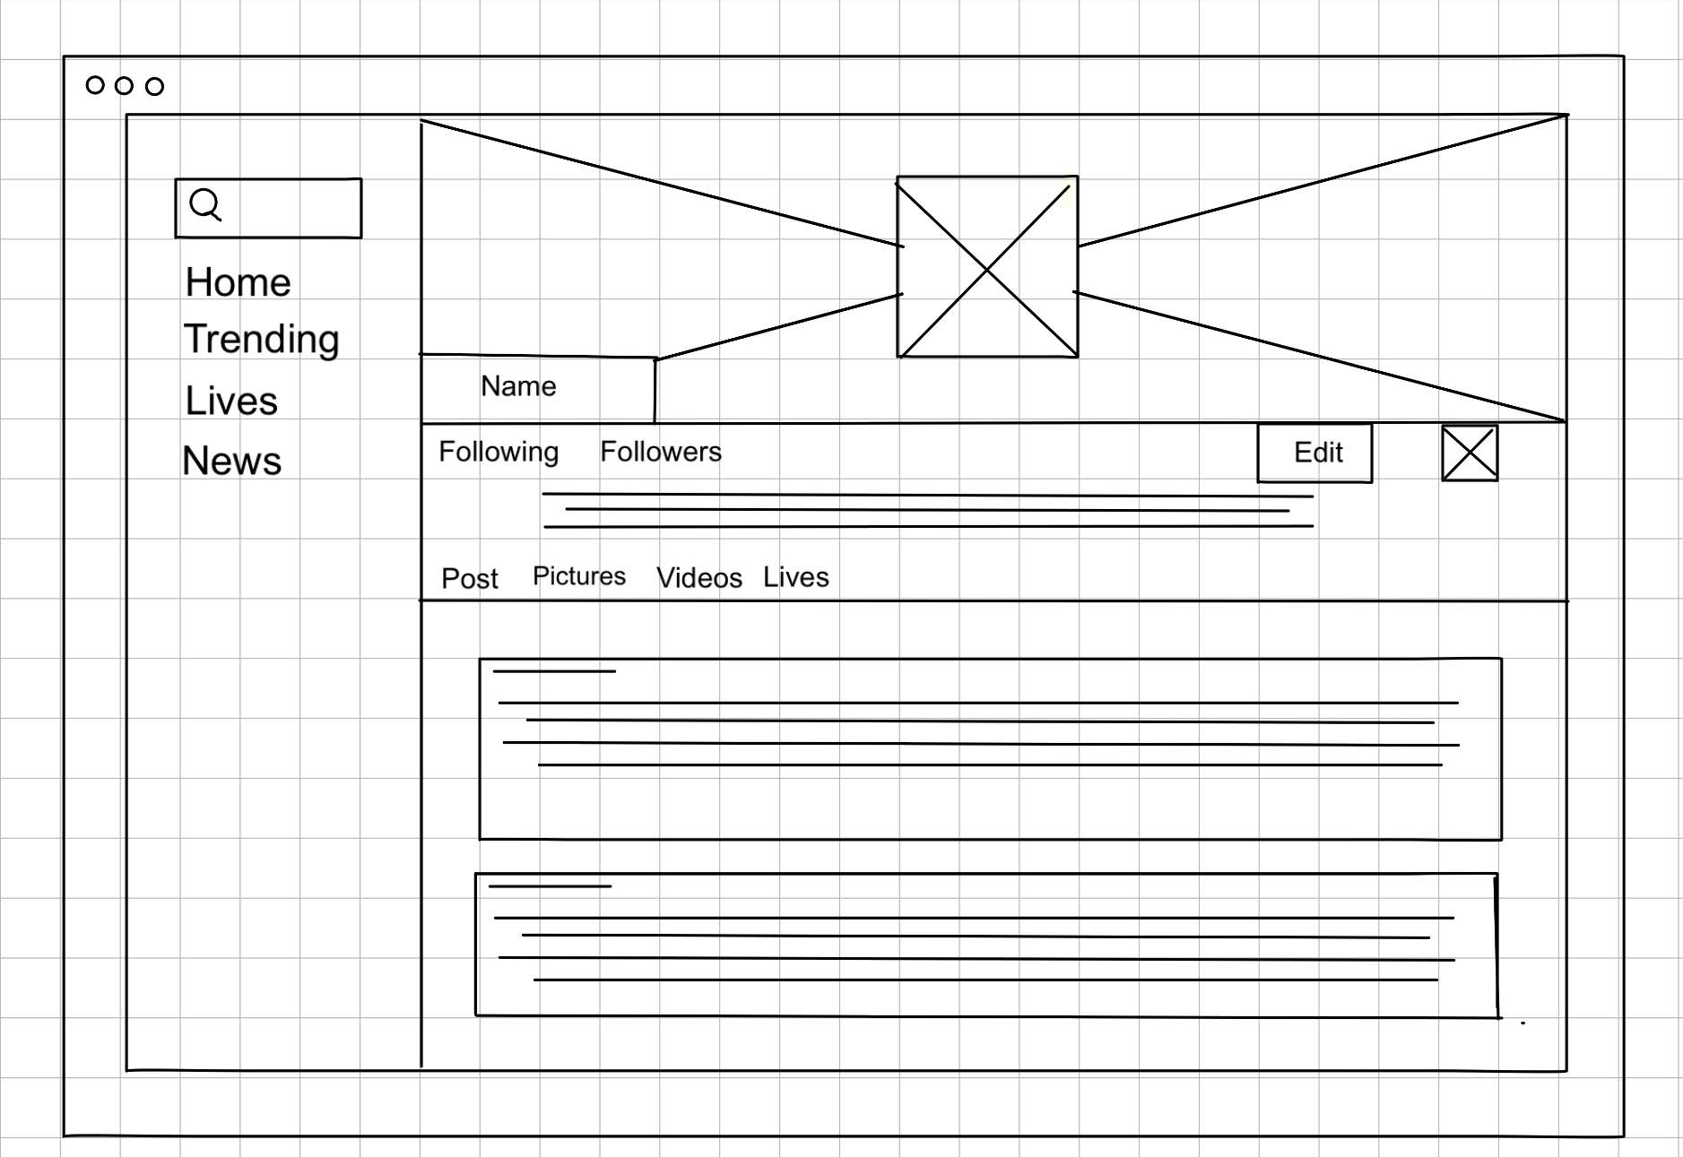

Home feed Page

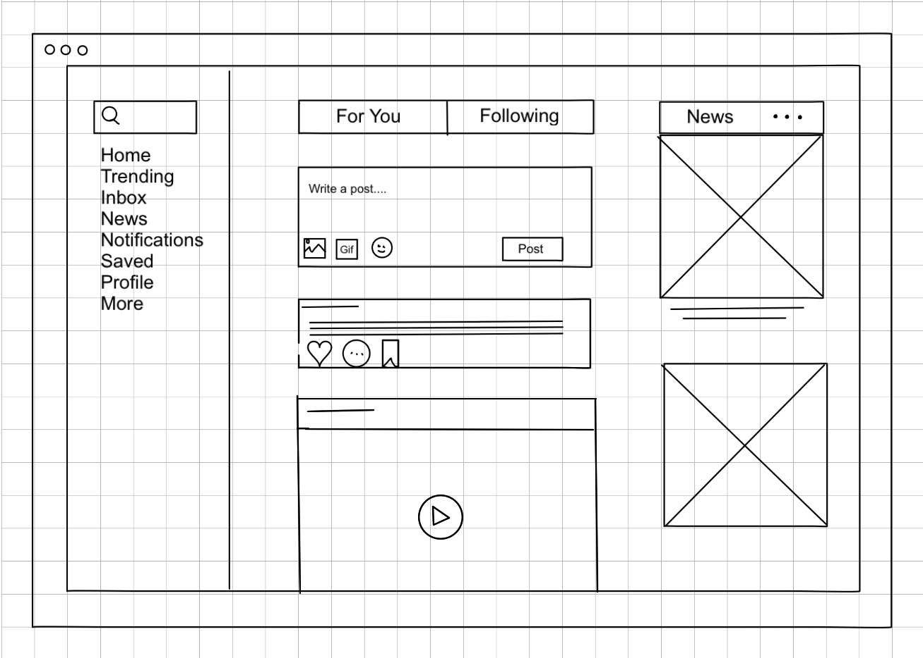

**Back end pseudo Code**

**User Profile:**

BEGIN

DISPLAY "User Profile Page"

INPUT userID

CALL fetchUserProfile(userID)

IF user profile is found THEN

DISPLAY user profile information (name, email, bio, profile picture, etc.)

DISPLAY "Edit Profile" button

DISPLAY "View Posts" button

IF "Edit Profile" button is clicked THEN

INPUT newProfileInformation (name, email, bio, profile picture, etc.)

CALL updateUserProfile(userID, newProfileInformation)

IF update is successful THEN

DISPLAY "Profile updated successfully!"

ELSE

DISPLAY "Failed to update profile. Please try again."

END IF

END IF

IF "View Posts" button is clicked THEN

CALL fetchUserPosts(userID)

DISPLAY user posts

END IF

ELSE

DISPLAY "User profile not found."

END IF

END

**Posting:**

BEGIN

DISPLAY "Create a New Post"

INPUT postContent

INPUT optionalMedia (image, video, etc.)

IF postContent is not empty THEN

CALL savePost(postContent, optionalMedia)

IF save is successful THEN

DISPLAY "Post created successfully!"

REDIRECT to feed

ELSE

DISPLAY "Failed to create post. Please try again."

END IF

ELSE

DISPLAY "Please enter content for your post."

END IF

END

**Like Post:**

BEGIN

DISPLAY "Like a Post"

INPUT userID

INPUT postID

CALL fetchPost(postID)

IF post is found THEN CALL checkIfUserLikedPost(userID, postID)

IF user has already liked the post

THEN DISPLAY "You have already liked this post."

ELSE CALL addLikeToPost(userID, postID)

IF like is successful THEN DISPLAY "Heart"

CALL updateLikeCount(postID)

ELSE DISPLAY "Failed to like the post. Please try again."

END IF

END IF

ELSE DISPLAY "Post not found."

END IF

END

**ERD diagram:**

